

adama science and technology university

school of electrical engineering and computing

department of computing

[Document subtitle]



PROJECT TITLE: F-JOBS

name ID

1. Kamil Aman A/UR4195/09

2. Daniel Mitiku A/UR4137/09

3. Burka Teshome A/UR4573/09

4. Abdena Belachew A/UR4322/09

5. Aboma Teshome A/UR4589/09

6. Mikiyas Leul A/ur4515/09

Contents

CHAPTER ONE 2

1.1 Introduction 2

1.2 Background 2

1.3 Statement of the Problem 2

1.4 Purpose of the project 3

1.5 Team composition 3

1.6 Objective of the project 4

1.6.1 General objective 4

1.6.2 Specific objectives 4

1.7 Feasibility 4

1.7.1 Technical feasibility 4

1.7.2 Operational feasibility 4

1.7.3Economic feasibility 5

1.8 Scope and limitation 5

1.8.1 Scope 5

1.8.2 Limitation 5

1.9 Significance of the project 5

1.10 Methodology 7

1.10.1 Information gathering & interviewing 7

1.10.2 Practical observation 7

1.11 Development tools 8

1.12 Testing procedure 8

1.12.1 Requirement testing 8

1.12.2 Unit testing 8

1.12.3 Integration testing 9

1.13 Overview of Project Phases 9

Chapter two 10

2. Description of the existing project 10

2.1 Major function of the current system 10

2.2 Users of the current system 12

2.3 Drawback of the current system 13

2.4 Business rule of the current system 14

Chapter Three 15

3.1 Proposed system (Overall description of the proposed system) 15

3.2 Functional requirement 15

3.3. Non-Functional Requirements: 16

3.4 Performance Requirements 17

3.4.1 Performance consideration 18

3.5 System model 20

3.5.1 Scenario 20

3.5.2 Use case model 25

3.5.3 Use case description 25

3.6 object model 29

3.6.1 Data dictionary 29

3.6.2 Class Diagram 30

3.7 Dynamic Model 31

3.7.1 Sequence Diagram 31

3.7.2 Activity Diagram 42

3.7.3 State Diagram 49

# CHAPTER ONE

## 1.1 Introduction

Today people lost their big time by finding jobs that relate with their knowledge so to get a job easily without losing their time; it could be using smart phone apps. A mobile app is computer program designed to run on mobile devices such as smart phones and tablet computers. F-jobs App is App that will going solve problems that phased when people find job. F-jobs can work in any Android mobiles or handled computer. With F-jobs, users can find free job advertisements by searching their fields and place.

Android platform or mobile operating system has chosen to implement this system. Android is a mobile operating system(OS) currently developed by Google ,based on the Linux kernel and designed primarily for touchscreen mobile devices such as smart phones and tablets(wikipedia.org).The project is developing F-job app using Android. In addition, when the application completed it can reduce the time consumed due to finding jobs and getting a jobs by our interesting city.

## 1.2 Background

As we know, Ethiopia is growing Country, so there are many candidates and jobless person in our country. To solve those problems Government and other in and outside country companies are working on it. Therefore, those government or company’s wants human resource and to get that they must go through paper advertisement and media. That cost too much cost and natural resources, i.e. paper and printing stuff. Research implies you can target a far wider audience without having to pay extra or alter your recruitment strategy. [46%](http://www.internetlivestats.com/internet-users/) of the entire world’s population uses the internet; in developed countries up to 80% of people have an internet connection. If you are looking for younger recruits, than e-recruitment is probably the single most effective and efficient strategy possible, because almost 100% of the 18-29 age group are daily internet users. To solve all these problems using web (Software) Technology by help of internet is the best option, so by using WWW or android apps you can get everything in one place.

## 1.3 Statement of the Problem

The overall activities of the FJOBS is under taken manually. Because of these manual activities problems like:-

* Lack of awareness/notification about job vacancy.
* Waste of cost on finding job.
* Confusion caused due to not knowing where the location of the job.
* Not being notified if there is a change on status.
* Waste of energy again to see there result.
* It takes excessive time to find the job location

## 1.4 Purpose of the project

* individual perspective
* All are notified and get enough information about job.
* Easily access to find a job through android systems.
* Know on online qualification for job.
* The system gives easy access for any valid users.
* From company and job provider perspective
* Easily evaluate the applicants or job seekers.
* Get full information about applicants.
* Update their exam date and inform other information’s.
* Make announcement about available jobs

## 1.5 Team composition

|  |  |  |  |
| --- | --- | --- | --- |
| **Name** | **Responsibility** | **Main Activity** | **Others** |
| Mikiyas Leul | Team leader | Coordinating and lead the members, make a work division b/n members , work on design implementation and documentation | Participate in all activities |
| Kamil Aman | Member | Work on requirement analysis, architecture, design, implementation  And documentation | Participate in all activities |
| Aboma Teshome | Member | Work on requirement analysis, architecture, design, implementation  And documentation | Participate in all activities |
| Abdena Belachew | Member | Work on requirement analysis, architecture, design, implementation  And documentation | Participate in all activities |
| Burka Teshome | Member | Work on requirement analysis, architecture, design, implementation  And documentation | Participate in all activities |
| Daniel Mitiku | Member | Work on requirement analysis, architecture, design, implementation  And documentation | Participate in all activities |

## 1.6 Objective of the project

### 1.6.1 General objective

The general objective of this project is to design and develop an android application system that can help any valid users to get access on available jobs. In addition, the system is usable for companies and organization to find job seekers on their available positions (works).

### 1.6.2 Specific objectives

* Study the existing available jobsites
* Take the good side of those system and identify their limitation
* Collect information about how the real world job process are works
* Collect the requirement which supports our system
* Select an appropriate tools for implementation
* Develop the full document
* Implement the document using the selected tools
* Test the system
* Provide detail information about the system should work for users.

## 1.7 Feasibility

A feasibility evaluates the project's potential for success; therefore, perceived objectivity is an important factor in the credibility of the study for potential investors and lending institutions. It must therefore be conducted with an objective, unbiased approach to provide information upon which decisions can be based.

The main concept here is that determining whether a proposed system can made or achieved this means checking the acceptance of the system, formally it is deciding the phase of acceptance. We analyzed three different types of feasibility test.

### 1.7.1 Technical feasibility

Implementation of the proposed system will use and run on Android smartphone operating system. Assuming required hardware and software resources are available for the development and implementation of proposed system. For example we use free or few cost software has to develop the system. This system will be developed using android studio. As we require some time to learn all these technologies, all these technologies are easy to learn and can develop system very rapidly. Therefore, we can say the project is technically feasible.

### 1.7.2 Operational feasibility

**• Process** – Usually the main inputs from the users are simple and easy. Therefore, users and the system will not have the difficulty of processing.

**• Evaluation** – The system will benefit anybody who uses it. If one jobseeker wants to apply one job and if the company is far away from his current place and does not have enough money to go to the company to apply our system help him to apply with lower cost than go to their.

**• Implementation** – implementation will be simple because all resource from inside and outside will be available will low cost/free and miner energy.

**• Resistance** – Since the system will be available only on android mobile operating system other mobile phone operating system users will not be able to run the system on their devices.

**• Adaptation** – Users will not need much time to adapt the system because the system is much user friendly and adaptable, its interface is easy to understand because it’s simple which is designed for user to easily understand the system.

### 1.7.3Economic feasibility

Proposed system requires development tools and software such as android studio, which are free of cost and available on internet. For developing proposed system, we need various resources such as computer systems, internet connection for help and for connecting with firebase recommended disk space, and memory speed as mentioned in technical requirements. By looking at all these expenses and comparing with proposed system, we have many benefits from proposed system such as: We connect with adMobs and we get some cash from that and we can deal with the companies who went to post their job and there is the payment for posting job.

## 1.8 Scope and limitation

### 1.8.1 Scope

The scope of the system includes register basic information, give information on open job for user/job seeker, and give information about the job, location and other helpful information of the job and information can be accessed in nationwide.

### 1.8.2 Limitation

In order to use this system, user needs to have basic mobile knowledge, must have the equipment to use the system and connect to the internet.

## 1.9 Significance of the project

Significances of this F-jobs Android System are:

**Cost Effective** – usually free to use! Not only is it cost effective because most platforms allow you to post your job openings for free but it also minimizes labor cost. In addition, if you invest a little bit of money in candidate screening software, you might be able to save even more money during the hiring process. Travel miles to for registration and to submit CV, but using the system he/she can register and submit his/her CV using one click directly to the company.

**Immediacy** – Providing information for users about the company and about the open job, most posts and replies appear in real time. It can help you either increase your efforts to attract more candidates, a different set of candidates (early instead of mid-career professionals, for example) and even stop candidates from applying if you have found the right person for the job. This further reduces the number of labor hours spent screening and informing job applicants about the status of their application.

**More Effective** – Minimizing the time wasted to find different vacancies for both user and company. Using android app is easily accessible to individuals making it a more effective method of getting your posts noticed in one application. Online job ads can be quickly shared on multiple platforms.

**Easy** – almost everyone can use online recruiting methods with very little training because it is clear, easy to understand and user-friendly. Many job posting websites work with the familiar functionality of social media platforms and email providers. They also help you categorize and set the region where you would like your job posting to be displayed.

**Dynamic Content** – posting jobs online and via our F-Jobs android applications gives you a chance to be more creative with your content and appealing to job seekers. Implementing technology can say a lot about your company and its culture and help attract a specific type of candidate. Minimizing the cost for users that are egger to find a vacancy e.g. providing the user to locate the nearby job using the GPS.

**Flexibility** – the app gives you much more flexibility about controlling your posts and the applications you receive. If you post in a newspaper, however, and want to amend the job advert, it is tough, and in most cases, you would need to pay for an entirely new ad. With online posts, most platforms will allow you to edit, update and remove your job post whenever you wish (For the company).

**Longevity** – newspapers or other forms of printed media have a very limited lifetime, dependent on their publishing cycle. Most classified publications have a bi-weekly publishing cycle, meaning that your address will only be seen for that relatively small amount of time. Online job posts on the hand will stay alive until the author or the website removes it.

**Accessibility** – no matter where you are if you have an internet enabled device and connection, and then you can do everything that I mentioned above.

**Expedited Hiring Process** – all of the previous advantages, lead to the biggest one of all; a shortened hiring process. Instead of waiting for a group of candidates to build up and then choosing from them, you will be able to access an enormous amount of applicants, which will inevitably lead to hiring a capable individual sooner.

## 1.10 Methodology

In consideration of the process that will unfold as the application is built these methods will be used

• We will first plan the stage we will go through

**•** Wright the SRS document describing what the system would look like fully

**•** Wright the SDD document having the design, interface and the look and feel of the system to the users.

**•** During every state we will consult potential users of our system to get a feel of the features that may want added.

**•** Then we had wright into coding and developing the system as described and outlined by our SRS and SDD document which by this time will have had all essential features as gathered from potential users explained deliberately.

**•** We then deploy the system for our and maintain it.

**•** All this steps are in according with the AGILE model of the development therefore it can be sold that we are using the model as our methodology.

### 1.10.1 Information gathering & interviewing

We have determined to do background research on those companies, who have the need for our software and that means. Those that have jobs to offer and are looking for workers the administration office of some of the cities in our county, namely Adama and Addis Ababa. To get information on what jobs are out there that are available, and the requirement to fulfilled to obtain a place out there. We will consult government and non-government offices to get information that will be helpful in the building process of our software.

### 1.10.2 Practical observation

In checking for the practicality, we will launch a campaign on the successful job. Finding applications out there like ethiojobs for our country, and other international job finding applications. To obtain the community’s response to each: their usefulness and success level. We will also dig into the open source software online projects out there and look for better ways and better code for our project. And because our project is highly focused on mobility and easy access of the service we will decompose and observe the mobile apps of other successful and non-successful job finding software programmers application files we can get our hands on. So that we may be able to apply the advantages, they have and reduce the failures they have encountered and create the innovative software of our generation.

## 1.11 Development tools

|  |  |  |
| --- | --- | --- |
| **Activities** | **Tools/ Programs** | **Purpose** |
| Client side coding | Android java programming, | A language used to develop the mobile application and a for the landing page that is used to download the app and description about the app |
| Platform | Mac OS X 10.11/ WINDOW 7/8or Linux and android debugger and android device | Operating system we can used to run our web page. Android device and debugger to debug the device. |
| Database server | SQLite, Microsoft sql. | We Use to manage and Store our Data |
| Diagram tools | Enterprise Architect &visual Paradigm | To develop UML diagram of the project |
| Browsers | All Internet Browsers | Browser is used to display web application via internet. Example Mozilla Firefox, Google chrome, internet explorer etc. |
| Editors | Macromedia ,Adobe Photoshop Android studio, Eclipse | Editor software used to edit some picture and web interface |

## 1.12 Testing procedure

### 1.12.1 Requirement testing

In this phase, we have focused on testing approach in which test cases, conditions and data are derived from requirements. It includes functional tests and non-functional attributes such as performance, reliability or usability.

### 1.12.2 Unit testing

In this phase, we have focused on testing the minimal software component, or module. Each unit (basic component) of the software is tested to verify that the detailed design for the unit has been correctly implemented. It is done at class level and resolves every missing syntax errors and semantics errors.

### 1.12.3 Integration testing

We will use this phase of testing during integration (implementation) of the F-JOBS to verify that it meets its requirements. It is used to resolve the readability of the system. It occurs after unit testing.

**•**We have focused on how individual software modules are combined and tested as a group. It occurs after unit testing

**•** prepare integration test planes.

**•** identify integration test objective.

**•** identify integration test acceptance criteria.

**•** perform the tests to our plan

**•** Document the test result.

## 1.13 Overview of Project Phases

In this software development process, we use agile method to develop our systems. Because agile method is an iterative, team-based approach development nature. This approach emphasizes the rapid delivery of an application in complete function component function components. Rather than creating tasks and schedules.

The typical software project includes the following phases:

**•** Requirements Analysis and Definition (System Overview).

**•** Functional Specification and UI Prototype

**•** Software Architecture and Test Plan

**•** Implementation (Coding) and Testing

**•** Operation and Maintenance

**1.14 Required Resource with cost**

|  |  |  |  |  |
| --- | --- | --- | --- | --- |
| **No** | **Cost type** | **Quantity** | **Unit price(birr)** | **Total price(birr)** |
| 1 | Flash disc | 1 | 250 | 250 |
| 2 | pen | 1pkt | 5 | 200 |
| 3 | paper | 1pkt | 0.33 | 133 |
| 4 | Transport |  |  | 300 |
| 5 | Coffee and Tea | 200 | 3 | 300 |
| 6 | Copy and print | 200 | 1 | 200 |
| Total price |  |  |  | 1383 |

# Chapter two

## 2. Description of the existing project

## 2.1 Major function of the current system

Based on our observation of the current system of online job sits, which give services for the Ethiopia society we can see that how those websites helps peoples to hire as well as to get jobs.

This is how the current system works:

**Web name:** Employ Ethiopia

**Web developers:** Natnael webinformation service plc admisters employethiopia.com

**Web description by developers:** Employ Ethiopia.com is a free online platform open for employee and job seekers to post search and apply for jobs online.

Employethiopia.com is now an integral part of people’s lives in Ethiopia when it comes to job search. Offering an absolutely free and state-of-the-art online recruitment platform for all kind of employers from the private and government sector across the country, employethiopia.com delivers attractive job content and information. Our content and online platform is freely available to, and devoured by, more than 90,000 of visitors and around 4,000 medium sized and small companies across the country. We are now among the top 50,000 websites in the world, with almost half a million post hits and more than a million page views in a month.

**Major function:**

● Provided language for users to access the information**:** English, Turkce, Chinese, Hindi

●Employer organizations: To place online job posts to advertise employment opportunity Information and collect applications, resumes (CVs) and supporting credentials (returnable or non-returnable) to compare, select and acquire qualified employees.

●Individual jobseekers: To post resume (CV) and other qualification information, to search for advertised jobs, to browse any category of jobs, companies and other employment opportunity information and apply for them online or as per the application procedures set out by employer organizations

**Web name: M-jobs**

**Web developer:** Somtec Trading PLC

**Web description by developers:** Mobile Jobs Ethiopia (M-jobs) is Ethiopia´s first sms based job search, which also features jobs online. It is founded and r

un by Somtec Trading PLC to assist job seekers into employment and connect employers with quality staff.

On mjobs.net, Employers upload their job vacancies and search for potentially suitable staff. When using Mjobs.net services jobseekers will save taxi fares to go and read noticeboards at a crowded street, buy newspapers that may or may not have posted jobs that they are looking for and no need to bother with slow internet connections at internet cafes. We send a jobseeker the vacancies that he/she is looking for directly to the registered mobile number.

**Major function:**

**●** the website shows how many active jobs are available for users (jobseeker)

For job seekers: You decide what kind of vacancies you receive by registering your profile. Whenever we find vacancies that you are potentially qualified for, we will send you a summarized full information on your mobile.

Range of features to help you search for a job, including:

●free registration for all seeking work

●jobs across all industries and regions of Ethiopia

●FREE SMS Job alerts sent directly to your mobile as per your preference and

Qualification.

For employers: In Ethiopia mobile users are 20 times more than internet users (1% internet users and 23% mobile users according to the International Telecommunications Union (ITU). This means we give you access to a wider audience in an instant by sending sms messages to potential employees that meet your job requirements as soon as you post vacancies.

Number of features to help you find the right person for your job, including:

●the ability to search for potential employees based on criteria in your advertisement

●high visibility of your jobs and instant reach of job seekers via SMS

● M-jobs was selected as one of the 40 best startups from 400 technology innovators from all over Africa

**Web name: ethiojobs**

**Web developers:** Info Mind Solutions PLC (IMS) a private limited company

**Web description by developers:**  is a premiere e-recruiting platform connecting leading employers with qualified job seekers in Ethiopia. Launched in 2004, Ethiojobs has progressively built a human resource bank now comprising more than 200,000 CVs.

Ethiojobs is the first recruitment solution provider introduced in Ethiopia. The website advertise jobs across a wide range of jobs types by different employee include private local, international, multinational, who are hiring in Ethiopia.

**Major functions:**

Ethiojobs offers the Site for the following permitted uses:

For an individual seeking employment: to post your personal resume (CV) and other information to obtain employment, and to search and apply for jobs, help wanted listings and other employment opportunity information;

For an employer seeking employees: to post jobs, help wanted listings and other employment opportunity Information to obtain employees, and to search resumes CVs and information posted by individual seeking employment.

● They provide job search tips

● Job search tips

● CV tips

● Career advice

**Other web based jobsites in Ethiopia:**

**Ezega.com**

**Job web ethiopia.com**

## 2.2 Users of the current system

The user of the current system (online jobsites) are different based on the information and availability of the websites. Some of the software’s have many users also the number of job posts and number of viewers are much greater than from other sits. However, the working principle of most job sits are same

The users of those job sits are:

● Job seekers

● Job providers (companies, private and governmental organization)

Companies, which found in Ethiopia, can use this sits to announce their job posts that are available for any valid users. The jobs can be from any fields of works like:

●Accounting and finance ●Driver, admin secretary

●Agricultural work ●Quality assurance job

●Management jobs ●hotel and hospitality jobs

●Health care service ●Natural science job…etc.

Some of the software’s gives extra services like news, events, career advice, CV tip and job search and job interview tips are there. Generally, any person who wants to get job related information also companies and organization, which provide jobs for Ethiopian people and others, can use.

## 2.3 Drawback of the current system

* **Receive unwanted applications:**

Once you post your job requirements on any of the portals that you have access to, the job seekers will get attracted towards it like bees, as it will be public posting. You will have no control on who is applying for post and hence there are high chances that the applicants might not be fit at all for the vacancy. This way you might have to filter huge number of unwanted resumes, which could be a pain area in the process of recruiting. However, there are options of filtering the candidates within the portal, which might give you some relief from the pain.

* **People from all over the world can apply**

There is no way you can put a filter where your job posting will be viewed by job seekers from a particular country or area. Such location requirements will have to be posted in the job requirement section, which many job seekers tend to ignore.

Hence, you can get large volumes of candidates who could fit in terms of the technical needs but might not be in terms of the location needs.

Job postings are viewed by everyone on the portal and it is not location specific.

* **Online Job posting doesn’t ensure filling up of vacancies**

There is no 100 % guarantee that once you have posted your job online, then your requirements will be fulfilled by receiving the resume of the right candidate.

No online portal will give you that assurance of an instant hit. Therefore, you might end up with the right candidate through the portal or with nothing at all.

It all depends on how the requirement is posted on the portal and what kind of applicants are applying for it.

* **Drawbacks of the current system(like Ethiojobs,Mjobs)**

Now the current systems as Ethiojobs applies in the requirement having people area, which reduces the amount of users as the majority of the people, are non-educated in our community. Moreover, excluding them would mean excluding the majority of people who can really benefit from the web/app form having a job. We should be the focus as they are the ones that are more in need of the app as they are the ones that struggle to make ends meet every day. The probability of having to provide them easy access to job/contracts and information about places that maybe in need of their capacities would help a lot. With respect to the normal graduate and diploma having people, looking for stabilized one-time jobs it is also taken into account.

* Lack of exact location of job area
* Some app are web-based application: - In Ethiopia mobile users are 20 times more than internet users (1% internet users and 23% mobile users according to the International Telecommunications Union (ITU).

## 2.4 Business rule of the current system

The following table illustrates the business rules of our proposed system.

|  |  |  |  |
| --- | --- | --- | --- |
| **ID** | **Rule Definition** | **Type** | **May change** |
| BR-1 | A person who wants to use this websites must have a smart phone or computers | static | static |
| BR-2 | There should be internet connection | computation | static |
| BR-3 | The user should have reading and writing skill of English or other language to get access of the systems. | fact | static |
| BR-4 | The system will synchronize (update) the application database in some period. | computation | Dynamic |
| BR-5 | Job providers must have to be verified to post there  announcement of jobs | fact | static |

**Table 2-1 Business rule of the current system**

# Chapter Three

## 3.1 Proposed system (Overall description of the proposed system)

The proposed system aims at developing an Android based mobile application that find a job for professional workers and nonprofessional worker.

Fjobs is developed to provide an effective means for the employers to post job openings with required qualification to have a better penetration into the job market and jobseekers to find out the information regarding the current openings in the organization. In addition, it also connects nonprofessional worker provider to the nonprofessional worker by giving the information.

The proposed system consists of the following advantages, time saving, provide information, Cost and Time efficient, portable.

## 3.2 Functional requirement

Defines functions of a software system or its components. They describe particular results of a system. So our Application helps job finders and companies to get job without any losing of time by finding advertisement and companies post their jobs easily by low cost.

In F-JOB

**Registration:**

The system will register Job seekers, companies (Employer), nonprofessional workers, and nonprofessional worker providers they fill their form through our system.

**Log in Activity:**

To enter to the system Admin, job seeker, nonprofessional worker provider, companies (Employer).

**Approving and Disapproving Activity:**

This Activity is done by admin to make our system reliable this Approving and disapproving is given to companies (Employer) and nonprofessional worker finders.

**See applicants:** The companies (Employer) can see the seekers that apply to their job.

**Applying Activity:** Job seeker do this activity to be posted job.

**Post Job:** Companies (Employer) can post their job vacancies.

**Manage posted job:** The Companies (Employer) can activate and deactivate posted job.

**Manage profile:** The system will provide a way to manage system users for the admins and users can edit there profile.

**Searching for job:**

Seekers can search posted job using field and nonprofessional worker finders’ search the seekers those registered using by they want.

## 3.3. Non-Functional Requirements:

They are requirements that specify criteria that can be used to judge the operation of a system, rather than specific behavior. Non-functional requirements define how a system is supposed to be. These are the constraint on the services or functions offered by the system the also in composes time constraint on development process and standards. They are more critical than individual requirement.

**Usability**

The system should be easy to learn and understandable for the user. That is every job finder can search the job that related to this field easily and companies and organization can post their advertisements easily so it must be easy to use so to make easy our application we are making the interface simple and not to be complex mainly our system works by our languages example Amharic.

**Reliability**

The system should be reliable. Mainly the System uses for job finders rather than organizations to make that admins contribute a big things by giving approves if a job seeker fill its form no one can see it’s form .

**Performance**

The system respond within 30milisecond. Because we use Google database so our system has good performance.

**Compatibility**

The system should have to be compatible. Since this system is Android application, so it is compatible for all Android phones.

**Accessibility**

The system should be accessible at any time since it is needed in every time. It is Android Application so everyone can use this Application by using smartphone. However, internet connection is required to be accessible.

**Maintainability**

The system should be maintainable. Because the interaction between subsystems will be loosely couple and the interaction between classes and operations will be highly cohered, changes made on our system such as adding other functionality shouldn’t affect the existing functionality of the system.

**Error Handling and Extreme Conditions**

Each error that may occur in F-job will be handled accordingly in order to reduce the amount of failure. Since users of our system are human, they may make mistakes, each input boxes are going to be handled according to their type.

**Documentation**

At the completion of the project, every activity of the entire development, design and other process will be documented for future reference. There will also be a documentation of implementation for maintenance during application failure. Furthermore, this will help for further maintenance and reusability of our system.

**Security**

These files which are going to be registered in the system have to be secured and must be kept in a secured manner. To satisfy these, we use firebase (Google Database).

## 3.4 Performance Requirements

**I. Hardware consideration**

For the application to run smoothly the following hardware specification should be considered.

●An Android device ex: touch phone, tablet, any device that runs on android (runs .apk files)

● Device features should include GPS, connection to an internet service provider

● Disk: 10MB

**II. Software consideration**

These below software conditions should be satisfied in order for the program to perform the purpose for which it was intended for example legacy versions of android OS might cause the application to crush or not perform properly.

● API level: minimum API level version 4.0.3 (Ice crème sandwich)

**III. Necessity**

the need for this system cannot be overemphasized as a majority of our youth are either unemployed or are employed in a job they either don’t like or that job doesn’t pay them enough to get by let alone lead a happy life thus it became necessary for us to make to make the information available for them to get the best available job at the best pay all over our country.

**IV. Documentation**

When all is finished everything the is in need of being know by either the user or other programmers will be documented also a how to use guide and other manuals will be published together with the software even the inner workings of the system will be included in the documentation.

**V. Accessibility**

The accessibility degree of this system can be in many directions.

1. The users can create profiles of log on to find available jobs or hiring people can came online to find people who have profile that meet the requirements they want.
2. Government (Mezegajia) workers can upload new jobs available and manipulate the job pages that they are administrating
3. For the users the services are available inside our country and the system is accessible anywhere where internet access exists so that even diaspora people can be set for a hiring of job(less likely) before they arrive here.

The accessibility of the system will also improve by integrating different frameworks.

In summary the accessibility standard will be fulfilled if the following conditions are

1. A working internet connection.

2. Government connection for new jobs finding and posting

3. and security verification system for authentication real users.

4. A connecting system (mostly by phone number and email) between users and job offering people

### 3.4.1 Performance consideration

Performance requirements define acceptable response times for the system functionality. Since system will be accessed by many different android devices with different capabilities and processing power. Therefore, it should be given more emphasis for the speed and response time of the application to acquire optimal response to the user. So that users that have different type of hardware can be equalized by the less need of hardware power of our system. In addition, those that have lower power having device will not be left out of the use of our software. The constraint characteristics also one of the performance characteristics of the system, the constraints can be user’s device low RAM, Network or connectivity failure with satellite and the internet and others. Therefore, our assumption regarding performance consideration:

●The load time for user interface screens shall take no longer than 5 seconds

●Available job search should be displayed in maximum 10 seconds

● New jobs offers shall be online maximum 10 seconds after upload.

● Categorization by desire shall be accomplished in 20 seconds.

● Database instructions shall return results within maximum 15 seconds.

● the system shall be easy to use and very interactive for user activity.

**I. Error handling**

For the purpose of the appearance of errors in our system, we will follow the instructive and corrective approaches

For the instructive we will have a very interactive interface which will guide our user to execute the task he want by making it easier for him to follow the steps in the accomplishment of the task

In the corrective method we will have system log service which in case of blockage error can sender error messages with their log(when and how they happened) and we could fix them and create a patch for the software

**II.Usability**

The system will be used by people who have jobs and are looking for other job or the same job with better pay

Hirers who are creating new business or want to find best workers with minimum cost of hiring

The government can use the system to best put in place the rightly qualified and best in their field available workers in its offices it can create job according to the observable work capability’s information found on the system

In addition to this the system hopes to create (a condition for moving people) a new Era, a new Reign, bread or type of people that are not held by one job but freelance from city to city and the country side in search of adventure and new places to settle An online provide for them contract job (money making ways) where ever they go in hope that they findtheir place in theworld .They can move and work at the same time until they find their settlement and the system will help them stay afloat until they finish whatever they are doing (very compatible with low income family students as it helps them learn while helping their family.

**III. User Privacy**

The system will only use information for the proper purposes like

Users info uploaded to our server will only be shown to job offering people that have been authenticated through our security and no record the user does not want will be shown

Or held against his will or knowledge and permission

For every information uploaded, the user’s permission will be consulted.

## 3.5 System model

### 3.5.1 Scenario

Scenario is a good approach to generate design idea for new system. It can help People understand better usage of the new system.

Users precondition

1. User must have smartphone running Android OS higher than 4.0 (Ice cream Sandwich)

2. The system or the Application must exist or installed on the user’s mobile phone (Smartphone)

3. The application need Network connection with the internet.

Flow of events:

1. User download the application.

2. User install the system on their smartphone

3. User starts running the system or application

**Scenario name: homepage**

**User Pre-condition:** system must be launched; connection must be on.

**Participating instance actors:** System user; Abdena.

Flow of events:

1. Abdena must lunch the application by tapping on the application’s icon.

2. Abdena must tap on the icon that will help him get the homepage of the system.

**Scenario name: register job seeker**

**Pre-condition:** system must be launched, connection must be on.

**Participating instance actors:** System user; Miki

1. Miki must lunch the application by tapping on the application’s icon.

2. Miki taps the register job seeker button.

3. Miki must fill the information about him and tap the register button.

**Scenario name: register employer**

**Pre-condition:** system must be launched, connection must be on.

**Participating instance actors:** System user; Dr. Chala

1. Dr. Chala must lunch the application by tapping on the application’s icon.

2. Dr. Chala taps the register employ button.

3. Dr. Chala must fill the information about him and tap the register button.

**Scenario name: login employer**

**Pre-condition:** system must be launched, connection must be on.

**Participating instance actors:** System user; Dr. Chala

1. Dr. Chala must lunch the application by tapping on the application’s icon.

2. Dr. Chala taps the login employ button.

3. Dr. Chala must fill the password and user name and tap the login button.

**Scenario name: post job.**

**Pre-condition:** system must be launched, connection must be on.

**Participating instance actors**: System user; Dr. Chala

1. Dr. Chala must lunch the application by tapping on the application’s icon.

2. Dr. Chala taps the login employ button.

3. Dr. Chala must fill the password and user name and tap the login button.

4. Dr. Chala must be approved by the admin, let as think like the one he is approved.

5. Dr. Chala must tap the button post job.

6. Dr. Chala must fill the information about the job and tap the button post.

**Scenario name: login job seeker, search job and apply**

**Pre-condition**: system must be launched, connection must be on, user must know what he/she want to search, and user should write the right spell of their search, must search by the job name.

**Participating instance actors:** System user; miki

1. Miki must lunch the application by tapping on the application’s icon.

2. Miki taps the login job seeker button.

3. Miki must fill the password and user name and tap the login button.

4. Miki taps the search bar and types accounting.

5. System will provide or list search results

6. Miki will tap on the first result with the job name accounting.

7. System will show detail information about that job.

8. Miki taps the apply button and apply for that job.

**Scenario name: Admin login and approve employee**

**Pre-condition:** system must be launched, connection must be on.

**Participating instance actors**: System user; Burka

1. Burka must lunch the application by tapping on the application’s icon.

2. Burka taps the login admin button.

3. Burka must fill the password and user name and tap the login button.

4. Burka must taps the button employee approve.

5. System will provide or list of the employees.

6. Miki will tap on the first employee.

7. System will show detail information about that employee.

8. Miki taps the approve button if he want to approve.

**Scenario name: Admin login and approve nonprofessional worker person**

**Pre-condition:** system must be launched, connection must be on.

**Participating instance actors:** System user; Burka

1. Burka must lunch the application by tapping on the application’s icon.

2. Burka taps the login admin button.

3. Burka must fill the password and user name and tap the login button.

4. Burka must taps the button nonprofessional approve.

5. System will provide or list of the nonprofessional worker finder persons.

6. Burka will tap on the first person.

7. System will show detail information about that person.

8. Burka taps the approve button if he want to approve.

**Scenario name: View applicant**

**Pre-condition:** system must be launched, connection must be on.

**Participating instance actors:** System user; Dr. Chala

1. Dr. Chala must lunch the application by tapping on the application’s icon.

2. Dr. Chala taps the login employ button.

3. Dr. Chala must fill the password and user name and tap the login button.

4. Dr. Chala must be approved by the admin, let as think like the one he is approved.

5. Dr. Chala must tap the button see applicant.

6. System will provide or list of the applicant.

**Scenario name: Register of unprofessional worker**

**Pre-condition:** system must be launched, connection must be on.

**Participating instance actors:** System user; Iyob

1. Iyob must lunch the application by tapping on the application’s icon.

2. Iyob taps the register unprofessional button.

3. Iyob must fill the information about him and tap the register button.

**Scenario name: Find nonprofessional worker**

**Pre-condition:** system must be launched, connection must be on.

**Participating instance actors:** System user; Mekdes

1. Mekdes must lunch the application by tapping on the application’s icon.

2. Mekdes taps the register unprofessional finder button.

3. Mekdes must fill the information about her and tap the register button.

4. Mekdes must approved by the admin, let as think that mekdes is approved.

5. Mekdes search for nonprofessional worker by choosing work from the list.

6. The system will provide the nonprofessional worker by searching by place and the work that mekdes needs.

6. Mekdes will tap on the first worker.

7. System will show detail information about that person.

8. Mekdes takes his information and get him by calling him.

**Scenario name: About**

**Pre-condition:** system must be launched; user must know what he/she want to browse

**Participating instance actors:** System user; Miki.

Flow of events:

1. Miki lunches the application by tapping on the application’s icon

2. Miki taps on the menu icon

3. Miki prompts Samson with menu list

4. Miki taps on about

5. Miki view about information

### 3.5.2 Use case model

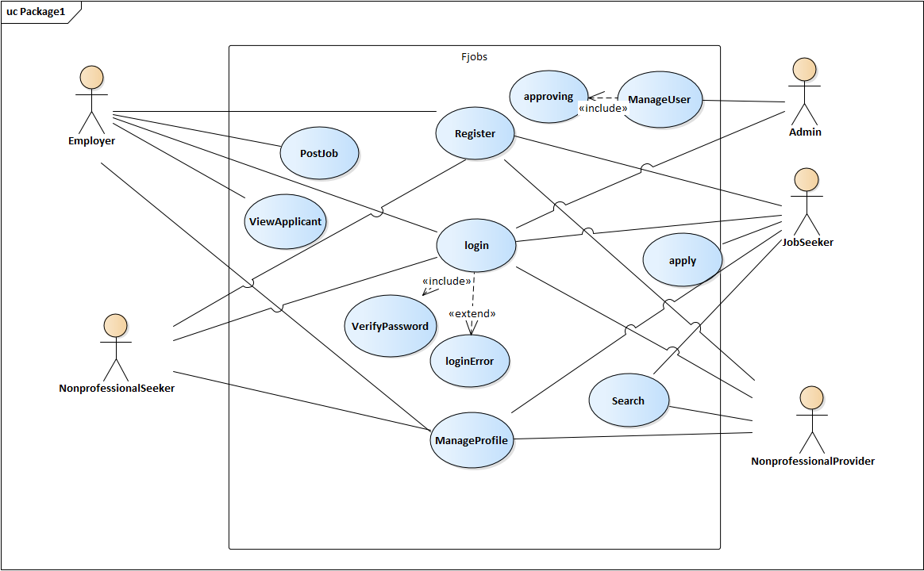

Figure 3.1 use case model

### 3.5.3 Use case description

|  |  |
| --- | --- |
| Use case id | 1 |
| Use case name | Register |
| Actor | Dr. chala |
| precondition | Dr. chala should have smartphone that is running android OS  Dr. chala must install the Fjobs  If Dr. chala must enter the information about him. |
| post condition | The system saves the entered data into database |
| Normal flow | Dr. chala opens the application the system and tap the button register and fill information and tap the button register |

|  |  |
| --- | --- |
| Use case id | 2 |
| Use case name | Login |
| Actor | Miki |
| precondition | miki should have smartphone that is running android OS  miki must install the Fjobs  Miki must register. |
| post condition | The system saves the entered data into database |
| Normal flow | Miki opens the application the system and tap the button login and fill username and password and tap the button login button. |

|  |  |
| --- | --- |
| Use case id | 3 |
| Use case name | Post jobs |
| Actor | Dr. chala |
| precondition | Dr. chala should have smartphone that is running android OS  Dr. chala must install the Fjobs  Dr. chala must register and approved by admin.  Dr. chala must login. |
| post condition | The system saves the entered data into database |
| Normal flow | Miki opens the application the system and tap the button login and fill username and password and tap the button login button then tap the tab post job and fill the information about the job and tap the button post job. |

|  |  |
| --- | --- |
| Use case id | 4 |
| Use case name | View applicants |
| Actor | Dr. chala |
| precondition | Dr. chala should have smartphone that is running android OS  Dr. chala must install the Fjobs  Dr. chala must register and approved by admin.  Dr. chala must login. |
| post condition | View update on the database |
| Normal flow | Miki opens the application the system and tap the button login and fill username and password and tap the button login button then tap the tab View applicants and see the list of applicant with their information. |

|  |  |
| --- | --- |
| Use case id | 5 |
| Use case name | Apply job |
| Actor | Miki |
| precondition | miki should have smartphone that is running android OS  miki must install the Fjobs  Miki must login. |
| post condition | The system saves the entered data into database |
| Normal flow | Miki opens the application the system and tap the button login and fill username and password and tap the button login button then tap the tab applied job and see the job applied. |

|  |  |
| --- | --- |
| Use case id | 6 |
| Use case name | manage profile |
| Actor | Miki |
| precondition | miki should have smartphone that is running android OS  miki must install the Fjobs  Miki must login. |
| post condition | View the profile on database |
| Normal flow | Miki opens the application the system and tap the button login and fill username and password and tap the button login button then tap the tab ManageProfile and view, delete, edit your profile. |

|  |  |
| --- | --- |
| Use case id | 7 |
| Use case name | Search |
| Actor | Abdena, miki |
| precondition | 1) Abdena should have smartphone that is running android OS.  Abdena must install the Fjobs.  Abdena must login.  Abdena must know what he want to search, and user should write the right spell of their search, must search by the job name.  2) miki should have smartphone that is running android OS  miki must install the Fjobs  Miki must know what he want to search, and user should write the right spell of their search, must search by the job name.  Miki must login. |
| post condition | View the nonprofessional workers on database. |
| Normal flow | 1)Abdena opens the application the system and tap the button login and fill username and password and tap the button login button then tap the tab search nonprofessional workers and view their information and take their information.  2)Miki opens the application the system and tap the button login and fill username and password and tap the button login button then tap the tab search job and write the job you want and tap the search button. |

|  |  |
| --- | --- |
| Use case id | 8 |
| Use case name | manage user |
| Actor | Admin |
| precondition | Admin should have smartphone that is running android OS.  Admin must install the Fjobs.  Admin must login. |
| post condition | The system saves the entered data into database |
| Normal flow | 1Admin opens the application and tap the button login and fill username and password and tap the button login button then tap the tab nonprofessional worker provider activation and activate /deactivate the nonprofessional worker provider.  2Admin opens the application and tap the button login and fill username and password and tap the button login button then tap the tab view info and the system provide the information from database.  3 Admin opens the application and tap the button login and fill username and password and tap the button login button then tap the tab employee activation and activate /deactivate the employee |

## 3.6 object model

### 3.6.1 Data dictionary

|  |  |  |  |
| --- | --- | --- | --- |
| Class | Attribute | Operation | description |
| Pro job Employers | empId, companyname | Login(),register(), manageprofile(), viewapplicant()  postjob() | They are companies or organization who wants valid professional job seekers |
| N-pro job employers | nonp.id | register(), login(), manageprofil(), searchNPworkers() | They are companies or organization who wants valid nonprofessional job seekers |
| job-seekers | Sek.id, educationlevel, experience, jobtype | searchjobs() ,applyjobs(),register(), login(), manageprofile() | They are persons who are looking for professional jobs |
| N-pro-job seeker | job type, experience | Register(),login(), manageprofile() | They are persons who are looking for non-professional jobs |
| Admin | admin id | Login(), manageprofile(), manageusers() | They are system creators or system controllers who control the working progress of the systems |
| user | firstname, lastname email, phone.no, address, username, password, age, gender | Register(), login(), manageprofile() | Any valid users can register and login into the system. |
| menu | Newsdescription, newsid, newstitle | News() | User can get news and information about the software through menu |
| joblist | Companyname, date, job.id, jobdescription, jobrequirement, jobtype, location, salary | Postjob() | User can access this class to find the jobs that was posted |
| Application | Sek.id, job.id | Applyjob() | Users can access this class to apply jobs |

### 3.6.2 Class Diagram

Class diagrams are used when developing an object-oriented system model to show the classes in a system and the associations between these classes. Loosely, an object class can be thought of as a general definition of one kind of system object. An association is a link between classes that indicates that there is a relationship between these classes.

Consequently, each class may have to have some knowledge of its associated class.  
When you are developing models during the early stages of the software engineering process, objects represent something in the real world, such as a patient, a prescription, a doctor, etc. As an implementation is developed, you usually need to define additional implementation objects that are used to provide the required system functionality. Here, we focus on the modelling of real-world objects as part of the requirements or early software design processes.

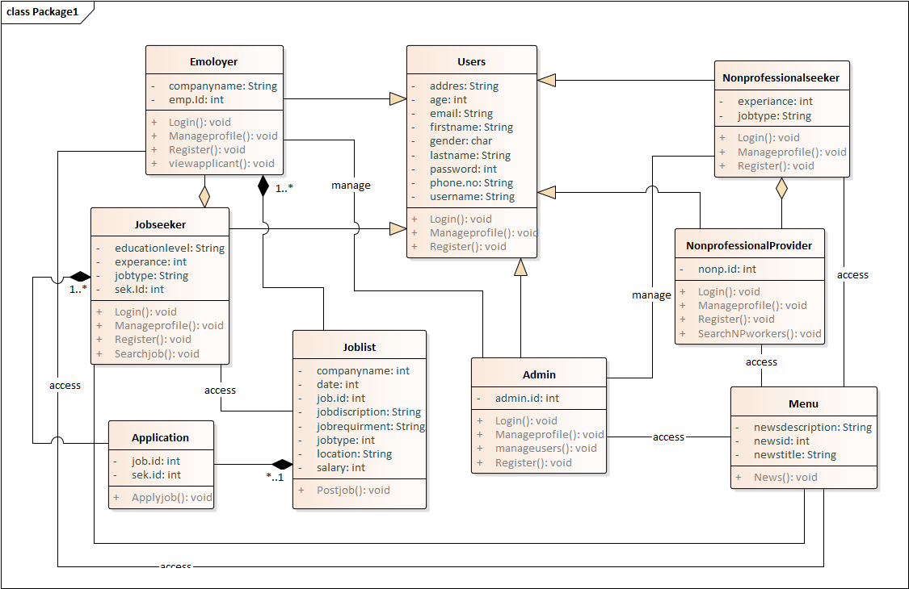

Fig 3.2 class diagram of F-jobs

## 3.7 Dynamic Model

### 3.7.1 Sequence Diagram

**Job seeker: -** The message sequence chart below shows implementation of the functionality of showing Jobseeker search job. The jobseeker search the job by his/her field or by region of our country.

1. Register: -is the job seeker sign in account by using email, name and password.
2. Login: - by his account login and enter to the app.
3. Search Job: - search jobs by field or country (region).
4. Apply: - apply for jobs.





Fig 3.3 Sequence diagram for Job seeker`

**Employer: -** The message sequence chart below shows implementation of the functionality of showing Employer Job post. TheEmployer (job post men) is see the applicant information when the jobseeker apply for job. Moreover, contact with jobseeker by call in phone number.

1. Register: - sign in and send request for Admin.
2. Login: - login by account.
3. Job post: - post the job for job seeker.
4. See Applicant: - see applicant information.





Fig 3.4 sequence diagram of Employer

**For Nonprofessional Jobseeker**: - The message sequence chart below shows implementation of the functionality of showing Non-professional. The nonprofessional jobseeker enter the information and manage his/her profile.

1. Register :- used to sign in and fill form
2. Login :- login for manage profile
3. Manage profile :- is update his profile edit again





Fig 3.5 sequence diagram of nonprofessional

**Non-professional job provider: -** the nonprofessional job provider see his/her information job seeker than contact by phone or other.

1. Register : - is work to sign in and register
2. Login: -is used for nonprofessional worker provider login the page
3. Search Worker: -search for nonprofessional worker and get information about





**Admin**: - this sequence diagram is used for the admin that shows how they work. Admin workers see the request of employer and nonprofessional worker provider. In addition, active and deactivate the request of Employer and nonprofessional worker provider. It is for the user’s safety.

1. Login: - login by account
2. Request: - approve the request(active/deactivate)
3. View : - view the information Employer and Nonprofessional worker provider



Fig 3.6 Sequence Diagram of Admin

**About**: - When the user went to get the information about the mobile application and about the developer. There is a message sequence chart below showing how to implement about functionality. Menu then about component, the user gets information from local sight database.

 Fig 3.7 Sequence diagram of about app

**Manage profile**: - any users can manage their profiles.so this sequence diagram show as how any valid users can manage their profiles.



Fig 3.8 manage profile

### 3.7.2 Activity Diagram

An activity diagram describes a system in terms of activities. Activities are states that represent the execution of a set of operations. The completion of these operations triggers a transition to another activity. Activity diagrams are similar to flowchart diagrams in that they can be used to represent control flow (i.e., the order in which operations occur) and data flow (i.e., the objects that are exchanged among operations).

**Activity diagram for login:**

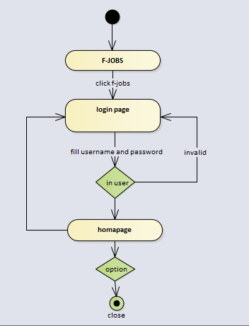

**Activity diagram for job seeker**

This activity diagram illustrate the basic activities of job seeker to search jobs, view profile, see detail about jobs and apply for the jobs that he/she want.

**Activity diagram for applying jobs:**

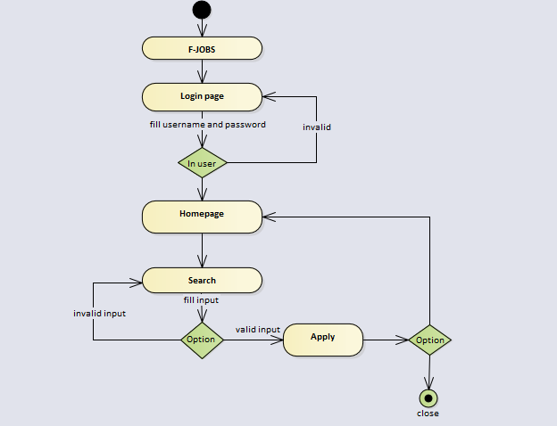

**Activity diagrame for searching jobs.**

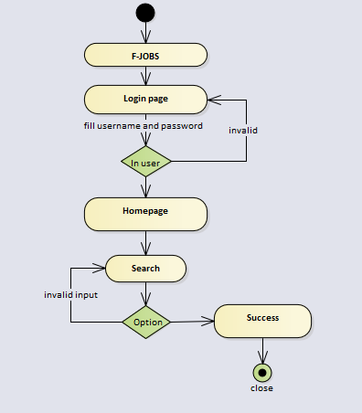

**Activity diagram for Nonprofessional worker provider**

The following activity diagram shows how the nonprofessional job provider provide jobs for the users of such kinds of jobs**;** also, they can get users information through this process.

**Activity diagram to see applicants:**

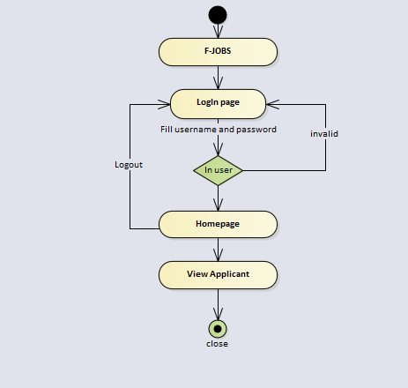

**Activity diagram for admin** the activity diagram illustrates the general functions of the admins for controlling the activity of employer’s, active/deactivate jobs and view the information about the whole progress.

**Activity diagram for approval of employers by admin:**

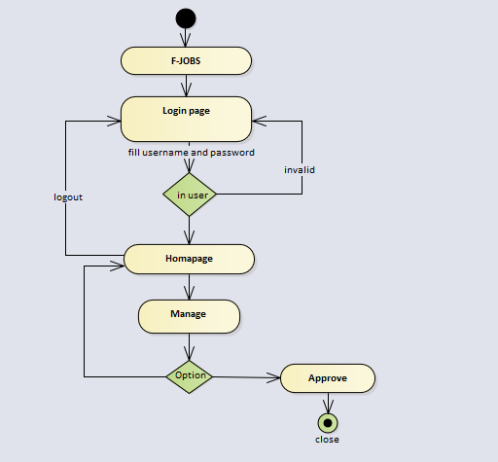

**Activity diagram for registration**

This diagram illustrates the registration process of how the work provider as well as the job seeker registers, create an account for up loading jobs and show first stage of system usability.

**Activity diagram for registration activity:**

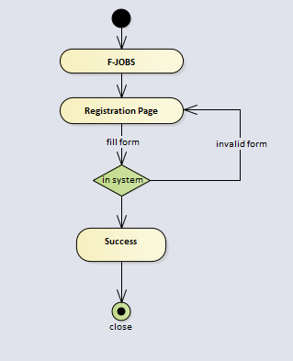

**Activity diagram for professional work providers (employers)**

This activity diagram illustrates the basic processing steps of employers to create an account for uploading available jobs, post jobs and active /deactivate the jobs that they posted on the pages.

**Activity diagram for managing account:**

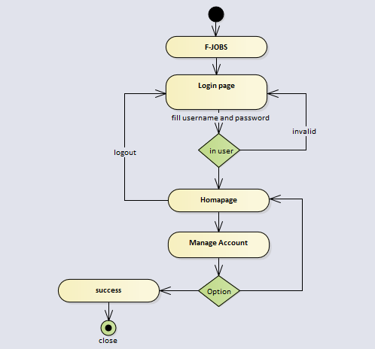

**Activity diagram for posting jobs:**

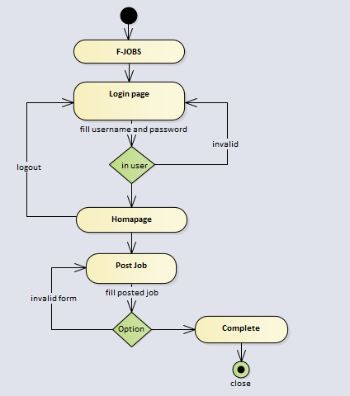

### 3.7.3 State Diagram

● **Registration State Diagram:**

The Diagram below shows how a new user can be introduced to the system by in rolling his information into the database. First User would load into the systems main page then By Clicking the Respective Login Tab (Respective means 1.job seeker 2.non pro worker seeker 3.Work uploader 4.pro job finder) then click the register button below the Log in button. Then in the registration page fill the required information then click register to be welcomed to the system

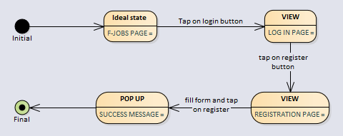

● **Log in State Diagram:**

The following state diagram show how a user can log in while communicating with the system from the main opening page. Where several news and stuff are found the user can switch to the Log in page by **Clicking the** **Log in tab,** then he/she can fill the information, and **Click the Log in Button** to log into the system.

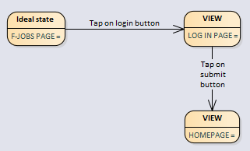

**●Worker finding** : people looking to hire nonprofessional workers can log in by click on their log in tab then fill username and password then click the log in button which will direct them to the workers list page form while they can select and click on to obtain the contact information of the particular person to hire

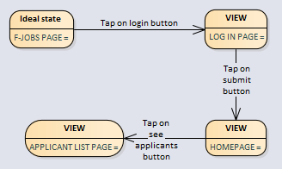

**●Job Posting:**

People who have been authorities as admins can log in by click on their log in tab then fill username and password then click the log in button which will direct them to the post jobs their they can fill the required information then click submit in order to put online jobs that have newly become available

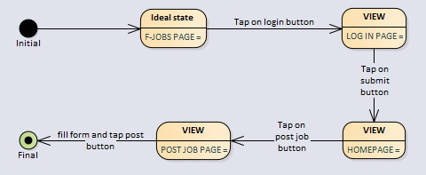

●**Activate/Deactivate accounts**:

Admins can also control the process of creating employer account by log in by click on their log in tab then fill username and password then click the log in button which will direct him/her to manage page then he/she can Active/Deactivate users account .

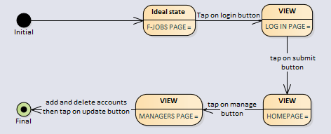

●**Job Search:**

This is how professional workers can search jobs, which they qualify. By clicking into log in tab then clicking log in button after username and password authentication. Then they can search by clicking the search icon will create a writing bar in which they can search the type of job in accordance with their specification then click search and the results will start pouring.

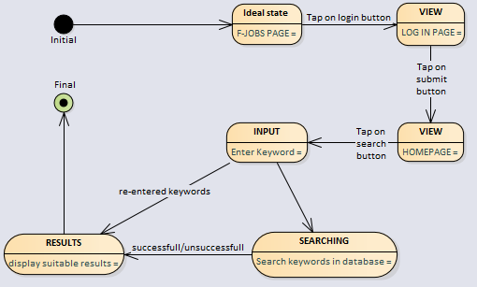

**See Jobs and apply (Professional Workers):**

Professional workers can look jobs by going from the main page into their log in page by clicking their login tab. Then they fill their username and password information, then if they are correct in identifying themselves a home page will show up with news and new helping information about jobs. Then click on the available jobs button to be introduced into the page that contains jobs available that are best according to our algorithm ordered alphabetically which they can scroll through.

